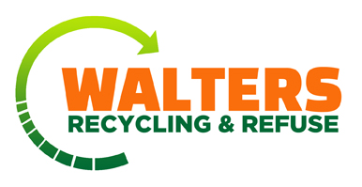
OPTIONAL
Automatic Bill Payment Authorization
Important – Please read and fill out completely

I hereby request Walters Recycling & Refuse, Inc. and authorize the financial institution named below to initiate the debit entries to my bank account to pay my waste removal bill. This authority is to remain in effect until Walters has received written notification of its termination in such time as to afford reasonable time to act upon it. I have the right to stop payment within ten (10) days of the billing date. I am responsible for notifying both Walters Recycling & Refuse, Inc. and the financial institution named below of this stop payment request. I understand that both Walters Recycling & Refuse, Inc. and the financial institution named reserves the right to terminate this payment plan or participation in it. I also understand that if I discontinue the program, I must notify Walters Recycling & Refuse, Inc. as follows:

RESIDENTIAL: Terminate by the 15th of the month prior to your next billing cycle.
COMMERCIAL: Terminate by the 1st of the month prior to your next billing cycle.

Funds will be withdrawn the first business day of the month your bill is due.

Please Print

Name: ____________________________________________ Date:________________

Home Phone: _______________________ Cell Phone: __________________________

By providing my cell phone number above, I agree to receive pre-recorded calls to that phone number.

Customer Number: _______________________________________________________

Name of Bank or Financial Institution: _________________________________________

Authorized Signature: _______________________________________________________

Please attach a voided check to this form and return it with your next payment.

Visit our web site at www.waltersrecycling.com
Call us at 763-780-8464 with questions or concerns. Thank you for your continued business!

